Inductors In AC Circuits

# Underlying Physics:

An inductor is an electrical component that stores electrical energy in a magnetic field (that opposes the direction of the current, when current flows through it). The inductance of an inductor is the ratio of the voltage against the rate of change of the current and is measured in henrys (H):

$v=L\frac{ⅆI}{ⅆt}$ $CITATION Ind2 \backslash l 2057 (Inductors And Calculus, n.d.)$ $∴L=\frac{v}{\frac{ⅆI}{ⅆt} }$

$L$: Inductance (in Henrys)

$v$: The voltage across the inductor (in Volts)

$\frac{ⅆI}{ⅆt}$: Change in current over time (in Amps per second)

A perfect inductor has no resistance, instead it has what is called Inductive reactance ${(x}_{L})$.

(Law of Induction, n.d.)

The reactance is the inductor resisting changes in the current or voltage in the circuit.

In an inductor the reactance occurs as when the current flowing through the inductor changes the magnetic field produced by the inductor gets stronger, and as the field opposes the direction of the current passing through inductor making it ‘harder’ for the current to flow, meaning it opposes changes in the current.

The reactance can be found using the equations:

$x_{L}=\frac{v}{I} and x_{L}=ωL=2πfL$ (Inductor AC Behaviour, n.d.)

$x_{L}$: Inductive Reactance

$v$: Voltage

$I$: Current

$ω$: Angular velocity (of AC source)

$f$: Frequency (of AC source)

$L$: Inductance

# Aim:

To find the inductance of an inductor in an AC circuit using measurements of the current, voltage and frequency of the supply.

# Apparatus:

* A signal generator 4.5kHz to 1.5kHz
* A digital oscilloscope
* A voltmeter (multimeter)
* An ammeter (second multimeter)
* A 0.5H Inductor

# Method:

## Setup:

The inductor and ammeter were set up in series with the signal generator as the supply.

The voltmeter was then set up in parallel to the signal generator to measure the supply voltage.

The oscilloscope was also set up in parallel to the signal generator to double check the frequency of the supply.

## Risk assessment:

High voltages may damage the apparatus, to avoid this the maximum voltage used was 5Vs.

There was little personal risk in performing this experiment as the voltages and currents used were all low.

## Circuit Diagram:

AC supply

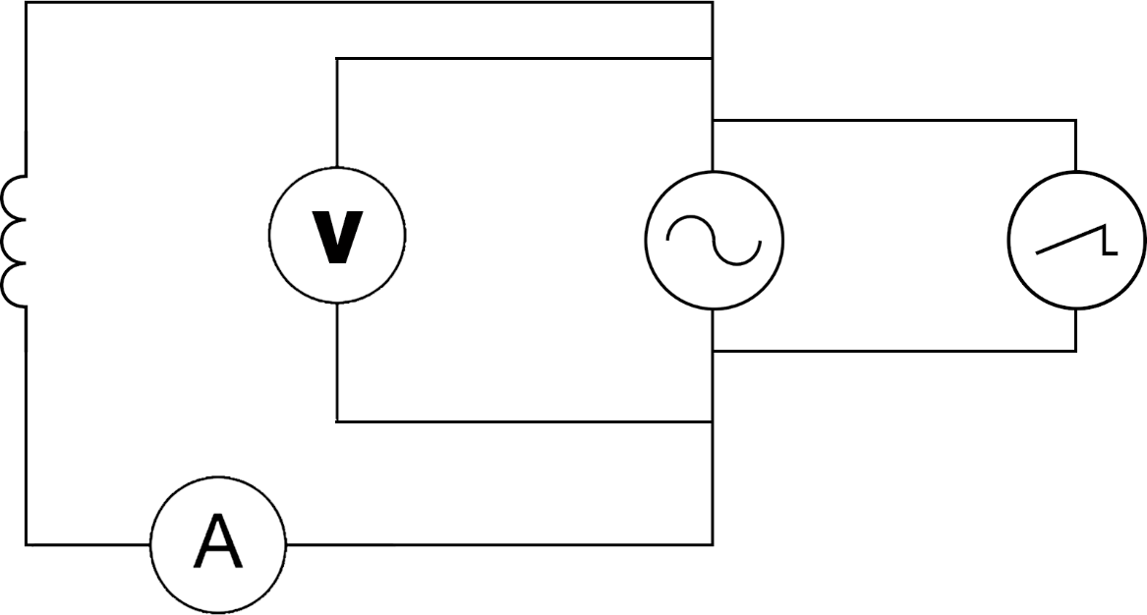

Ammeter

Voltmeter

Oscilloscope

## Procedure:

The signal generator was set to a frequency which is checked using the oscilloscope, the voltage was adjusted to be 5V, double checking using the voltmeter, and the current was measured using the ammeter, then the signal generator was switched off and on again to get a repeat reading. The frequency was then lowered by 0.5kHz and repeat. The range of frequencies measured were from 4.5kHz to 1.5kHz.

# Results:

|  |  |  |  |  |  |  |  |  |  |  |  |  |  |  |  |  |  |  |  |  |  |  |  |  |
| --- | --- | --- | --- | --- | --- | --- | --- | --- | --- | --- | --- | --- | --- | --- | --- | --- | --- | --- | --- | --- | --- | --- | --- | --- |
|  | | |  |  | | Current (mA) | |  | |  | |  |  | |  | |  | | |  | |  |  |  |
| Frequency (KHZ) | | 1/F (s) | Voltage (V) | | 1 | 2 | 3 | 4 | | 5 | | avg |  | |  | |  | | Δtotal | Δ% | |
| 4.5 | | 0.0002222 | 5 | | 0.442 | 0.444 | 0.444 | 0.445 | | 0.445 | | 0.444 |  | |  | |  | | 0.022231 | 5.006894 | |
| 4 | | 0.00025 | 5 | | 0.527 | 0.526 | 0.525 | 0.525 | | 0.525 | | 0.5256 |  | |  | |  | | 0.026302 | 5.004197 | |
| 3.5 | | 0.0002857 | 5 | | 0.623 | 0.622 | 0.622 | 0.622 | | 0.622 | | 0.6222 |  | |  | |  | | 0.031127 | 5.002686 | |
| 3 | | 0.0003333 | 5 | | 0.752 | 0.749 | 0.75 | 0.749 | | 0.749 | | 0.7498 |  | |  | |  | | 0.037508 | 5.002418 | |
| 2.5 | | 0.0004 | 5 | | 0.921 | 0.918 | 0.917 | 0.916 | | 0.917 | | 0.9178 |  | |  | |  | | 0.045912 | 5.002374 | |
| 2 | | 0.0005 | 5 | | 1.152 | 1.151 | 1.15 | 1.15 | | 1.15 | | 1.1506 |  | |  | |  | | 0.05754 | 5.000876 | |
| 1.5 | | 0.0006667 | 5 | | 1.531 | 1.529 | 1.53 | 1.527 | | 1.529 | | 1.5292 |  | |  | |  | | 0.076471 | 5.000701 | |

# Uncertainties:

Current uncertainties (mA):

|  |  |  |  |  |  |
| --- | --- | --- | --- | --- | --- |
| averages | Δcal | Δread | Δrand | Δtotal | Δ% |
| 0.444 | 0.0222 | 0.001 | 0.0006 | 0.022231 | ≈5 |
| 0.5256 | 0.02628 | 0.001 | 0.0004 | 0.026302 | ≈5 |
| 0.6222 | 0.03111 | 0.001 | 0.0002 | 0.031127 | ≈5 |
| 0.7498 | 0.03749 | 0.001 | 0.0006 | 0.037508 | ≈5 |
| 0.9178 | 0.04589 | 0.001 | 0.001 | 0.045912 | ≈5 |
| 1.1506 | 0.05753 | 0.001 | 0.0004 | 0.05754 | ≈5 |
| 1.5292 | 0.07646 | 0.001 | 0.0008 | 0.076471 | ≈5 |

These were calculated using the results gathered:

Δcal: this was 5% of the average, this was found in an instruction manual.

Δread: As the multimeter used to read the current was digital this is the smallest unit the multimeter can read.

Δrand: This was calculated using the results gathered: the greatest reading – the lowest reading / the number of readings.

Δtotal: $\sqrt{{\left(Δcal\right)}^{2}+{\left(Δread\right)}^{2}+{\left(Δrand\right)}^{2}}$

Δ%: (Δtotal/the average)*100

Voltage uncertainties (V):

∆cal = 0.8% + 3 of the least sig figs =

0.07 (0.04 + 0.03)

Δread = 0.01

Δtotal = 0.071

∆% = 1.42%

Frequency uncertainties (Hz):

Δcal was 1x10-2

Which is so small it’s negligible.

Δread = 0.001

Which is also so small it’s negligible.

Δtotal = N/A

# Graph:

gradient = 2.432703936 As-1

intercept = -7.52532x10-5 A

∆ gradient = 0.044827 As-1

%∆ gradient = 1.842698475 $≈$ 1.84%

These values were obtained using the LINEST function in the excel file results were recorded in.

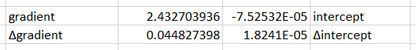

# Calculations:

|  |  |
| --- | --- |
| $$x=\frac{v}{I}=2πfL$$ $$I∝\frac{1}{f}$$ $$I=\frac{v}{2πL}\frac{1}{f}$$ This equation can be put in the form of a straight line formula: $$y=mx+C$$ $y$ represents $I$, $x$ represents $\frac{1}{f}$ and $m$ represents $\frac{v}{2πL}$ $$m=\frac{v}{2πL}$$ $$L=\frac{v}{2πm}$$ $$=\frac{5}{2π×2.4327}$$ Using the value of the voltage measured and the value of the gradient from the graph found using the linest function. $$=0.32711$$ $$≈0.327H$$ | $$ΔL=\sqrt{{\left(\%Δm\right)}^{2}+{\left(\%ΔV\right)}^{2}}$$ $$=\sqrt{{1.84}^{2}{+1.42}^{2}}$$ $=\sqrt{5.402}$ $=2.3242202$ $≈2.32\%$ $$ΔL=0.0075864$$ $$≈{8×10}^{-3}H$$ |

# Conclusion:

The average inductance of the inductor was (0.3278x10-3) H over a range of 4.5-1.5 KHz

# Evaluation:

Looking at the graph reveals that there was a systematic error in the experiment as the line of best fit does not go through the origin, the intercept is ≈-7.5x10-5 when it should be 0. To reduce this error, I could have used a more modern signal generator as while I used the oscilloscope to double check the frequency and the voltmeter to double check the voltage, these values weren’t exactly on the desired ones and they constantly fluctuated slightly, using a more modern signal generator would likely reduce this effect, for example a digital signal generator would be more accurate.

I would also lower the range to around 150Hz as the given value for the inductance of the inductor I used was 0.5H at 50Hz. This may not decrease the uncertainty but it would make analysing the results easier.

# References:

*Electrical Reactance*. (n.d.). Retrieved from Wikipedia: https://en.wikipedia.org/wiki/Electrical_reactance

*Inductor AC Behaviour*. (n.d.). Retrieved from HyperPhysics: http://hyperphysics.phy-astr.gsu.edu/hbase/electric/acind.html#c2

*Inductors And Calculus*. (n.d.). Retrieved from All About Circuits: https://www.allaboutcircuits.com/textbook/direct-current/chpt-15/inductors-and-calculus/

*Inductors and Self-Inductance*. (n.d.). Retrieved from Scholar: https://courses.scholar.hw.ac.uk/vle/scholar/session.controller?action=viewContent&contentGUID=608DF5CD-C8D7-5769-8353-AEB994AB55B1

*Inductors in a.c circuits*. (n.d.). Retrieved from Scholar: https://courses.scholar.hw.ac.uk/vle/scholar/session.controller?action=viewContent&back=topic&contentGUID=509D792F-3028-352E-B2B6-A7BBF3508723

*Law of Induction*. (n.d.). Retrieved from Wikipedia: https://en.wikipedia.org/wiki/Faraday%27s_law_of_induction